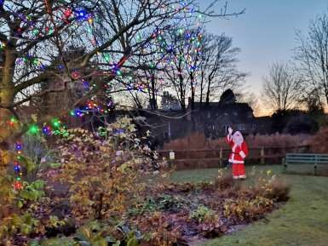

The Newsletter for Middleton on the Wolds

Issue No 22

December 2020

(
Incorporating January
2021)

NEXT COPY DATE
14th January

Please send in your contributions to middletonflyer@yahoo.com by the end of the copy day. If I don’t acknowledge them please get in touch to make sure they have arrived.
As you will recall from previous years a break is taken
at this time of year so the next Messenger will be in February. I will look forward to receiving your contributions for that in the middle of January.
Thank you to everyone who has given articles and photos throughout this year; without them arriving in my inbox or letterbox each month there wouldn’t be a Middleton Messenger!

With warm wishes for a Happy Christmas and hopes for a better year for us all in 2021
Lyn
4 The Paddocks 219500

editorial
As the great Noddy Holder once said: ‘IT’S CHRIIIIISTMAAAAAS!!!!’ or, at least, it nearly is. Blimey, where did that year go? It will certainly go down as one of the strangest ever for all of us and I know it’s hard to find any positives from it – but here goes:
- As a nation we are becoming less selfish and there is definitely a stronger feeling of
community. Most people have done their best to follow self-distancing and isolating guidelines not just for themselves but because they know that it will protect others. Many have also volunteered to help the vulnerable or simply those in need.
- More people are taking some kind of exercise. Anything that makes us healthier can’t be bad.
- There’s less traffic than normal. Okay, it’s mostly due to less of us having to go to work but at least the air is cleaner.
- More of us are working from home. That means a shorter working day, more flexible hours, and less commuting.
Basically, we’ve all had to become more flexible in how we respond to new challenges the situation has given us, which brings me to Christmas. It looks like it might be a little different for some of us this year but what’s wrong with a bit of change every now and then? I know Christmas is a time of tradition and of family but, rather than concentrate on what we will be missing, why not try thinking about how you can make it a Christmas to remember – for the right reasons.
Whatever you do, stay safe.
Merry Christmas,
Mike

If you have any ideas, comments or complaints (especially complaints) you want to share then send an email to middletonflyer@yahoo.com.
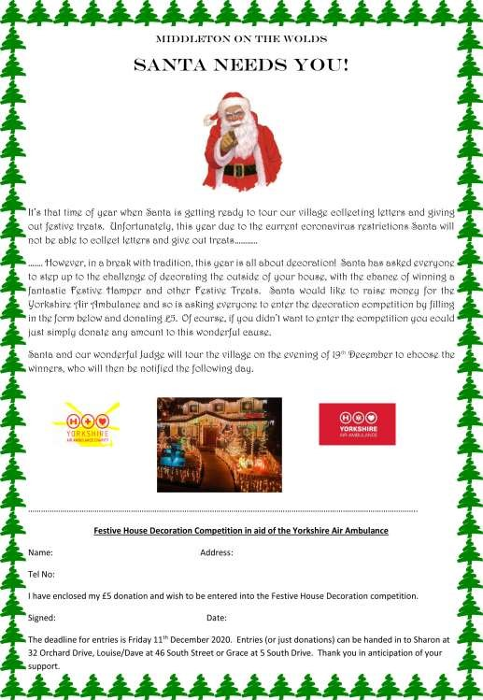

QUIZ PAGE
- How many points does a snowflake have?
- Solve the Christmas anagram: tense aggressions?
- What are the Names of The Three Wise Men?
- How does Good King Wenceslas like his pizzas?
- Who said "God Bless Us Everyone"?
- What was Elvis Presley's sad Christmas Song?
- What did The Little Drummer Boy give to the Christ Child?
- Name of the 1992 Muppet Christmas Film?
- Which member of ‘The Royle Family’ was born on Christmas Day?
Who had TV "Christmas Special's" usually broadcast on Christmas Day, each
- year?
Quiz set by Rowland Wooldridge
^{SUDOKU} SEASONAL DINGBATS
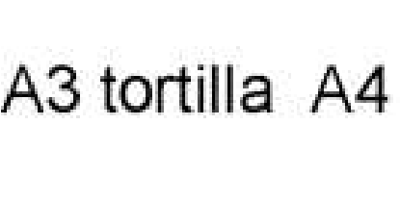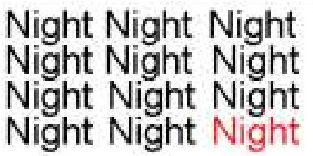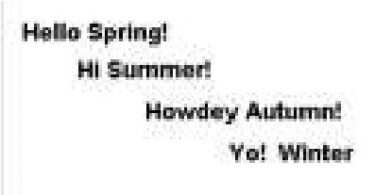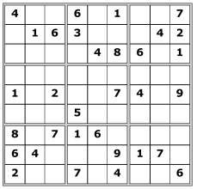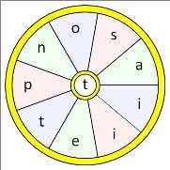
All answers on page
20

WORD WHEEL

The goal of a word wheel puzzle is to
create as many words possible with the
letters in the word wheel. You can only
use each letter once and every word must
have the letter in the centre of the wheel.

The 10 letter word is on the answer page.

LOCAL HISTORY
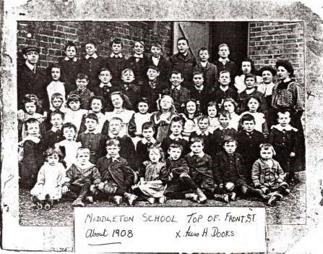

SCHOOLDAYS – SLOW PROGRESS

From 1881 to 1892 John Gush and his wife Elizabeth, both from Dorset, were in charge of the school. In addition to parental conflict the school had to contend with underfunding, lack of equipment (a request for a dictionary was refused) restricted space, frequent changes and illnesses of staff and over zealous use of physical punishment by some teachers. Children were often poorly clad and fed and had in some cases to travel long distances from overcrowded and unhealthy homes. In winter the schoolroom was heated by an open fire which provided scant warmth and diseases such as mumps, measles, influenza, diphtheria, chicken pox and even smallpox and typhoid made their presence felt in the village. Other excuses for absence were the Kiplingcotes Derby, Martinmas Hirings, Feast Days in Middleton and neighbouring villages, visiting menageries, sales and activities of rival religious groups while the schoolroom itself was often used for other activities such as concerts and the village clothing club.

Mr Gush received three months notice to leave in 1892 on account of unfavourable reports and he asked the managers to consider whether they provided the school with sufficient staff and had done their best to achieve regular attendance. Mr Gush stayed on in the village for a while after his successor Henry Phillips, a Staffordshire man, took over and claimed his dismissal had been because of his political views. He subsequently became head of a school in Devon and died in 1935.

Two happenings helped to change the course of education the first being the creation of the County Council in 1888 which gave a firmer structure to local administration and the second the hotly contested Balfour Education Act of 1902 which set the ball rolling for future secondary education.

A new classroom was provided in 1906 and the existing one enlarged. Gardening was introduced into the curriculum to provide experience of manual work and a new piano was bought with the help of fund raising activities. In this Edwardian period patriotism was in vogue with celebrations on Empire Day while military drill became part of the school routine for boys and a Swedish variety for girls . Cricket, a more sedate pastime, was played in the Hall grounds with the permission of the Brooksbank family. The school had four headmasters during this period and it was during these years that medical inspections were introduced and household management for girls started and by this time the number on the school roll was reaching 100 plus. An extract from the school log in 1914 is revealing:-

“ July 24 parents’ day. The school was thrown open today from 2 pm to 4 pm for visits of the scholars’ parents. Many availed themselves of the opportunity and the ordinary lessons were taken till toward the close when country folksongs and dancing were enjoyed. The innovation was a success. Average attendance for the week being 89.49%.” Another progressive feature that week was the attendance of Mrs Purchon on a one week course at the summer school of the Education Handwork Association.

The report on Middleton school that year stated “The present strong staff of loyal industrious teachers directing their efforts to securing increased and steadier mental effort from the children should increase the general efficiency of the school.” So the school broke for the summer vacation in 1914 with a feeling of optimism: it was not to last.

Geoff Wisher
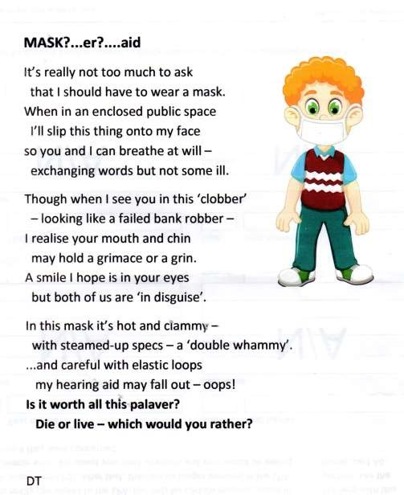
Thank you to Betty Lowe for sending in the poem, cartoon and recipe.

LEMON PAVLOVA
THIS RECIPE MUST BE FROZEN
Meringue
6 egg whites Whip egg whites until white and very stiff, gradually adding sugar. Fold in cornflour and 12 oz castor sugoar vinegar.
- teaspoons cornflour
Make 2 rounds with meringue. Cook on silicon ^{1 teaspoon vinegar} paper for 1 hour at 130 or reg 1 1/2. Then 1/2 hour with oven off for meringue to “dry out”.
^{Filling} Beat egg yokes with sugar, add juice and rind of 6 egg yolks lemons. Place in double pan on cooker until very 4 oz castor sugar thick. Cool. Add whipped cream.
- lemons Sandwich meringues together with filling and 8 oz double cream freeze.

Remove 1/2 hour before eating to ensure filling is still very cold.

The wolds METHODIST CHURCH bainton

Services at the Wolds Methodist Church are on hold until the current restrictions are lifted.

Parish council
Hopefully everyone in our village is keeping safe and also looking out for their neighbours, anyone living alone or any vulnerable people nearby during this latest lockdown period. We have many kind and caring individuals and groups of people helping others. (See below)
The Parish Council Co-Opted two new members; Mrs Linda Jones and Mr Peter Roe. We now have a full council again and I would like to welcome both Linda & Peter who I am sure will be valued members with a strong interest in the village.
Traffic issues seem to be a constant item on the agenda with many parishioners concerned about the size and quantity of vehicles, along with large vehicles using unsuitable routes. We have the support of our Ward Councillor on these issues and hope the speeding issues can be calmed by the introduction of the Speedwatch scheme, and any future diversions could be via alternative diversion routes.
Many people living on Front Street are concerned about the condition of the road surface and sunken manhole covers. We have regularly reported this to the authority and encourage residents to contact the ERYC Highways Department themselves to express how disturbing this is during day and night time; and the effect it is having on their quality of life.
Finally on a brighter note the Christmas festive lights on the village green will be erected bringing much needed sparkle into our lives. John Eastwood

HELP DURING CORONAVIRUS RESTRICTIONS
Lockdown makes it more difficult to live normally. If you do feel that you need help with anything from getting medical help to simply having a chat please contact any of the parish councillors and we will be able to point you in the right direction. But we can't help you if you don't let us know.
Mike Kelly
07713 620912

St Andrew’S church
December and January Services

All Services are subject to Covid restrictions in force at the time.

Sunday 6th. December. No Service

Sunday 13th. December Morning Prayer at 10.30.a.m. Revd Jane Anderson. Sunday 20th. December Morning Prayer at 10.30.a.m. Revd Canon Kate Goulder.

Thursday 24th. December Christmas Eve. Midnight in Bethlehem Service at 10.00.p.m.Revd Jane Anderson.

Sunday 27th.December. No service.

If the Covid regulations are lifted during December, then a celebration of Holy Communion will be held in place of Morning Prayer. All are welcome to attend a service at this very special time of the year.
A VERY HAPPY CHRISTMAS TO ALL
Depending on Covid restrictions there will be a service at 10.30.a.m. on the Sundays in January. Details at the time on Post Office notice board.

We are planning for a joint Benefices I.e. Waggoners & Woldsburn service to celebrate Epiphany on Sunday 10th. January at 10.00.a.m. at Middleton. Details later.

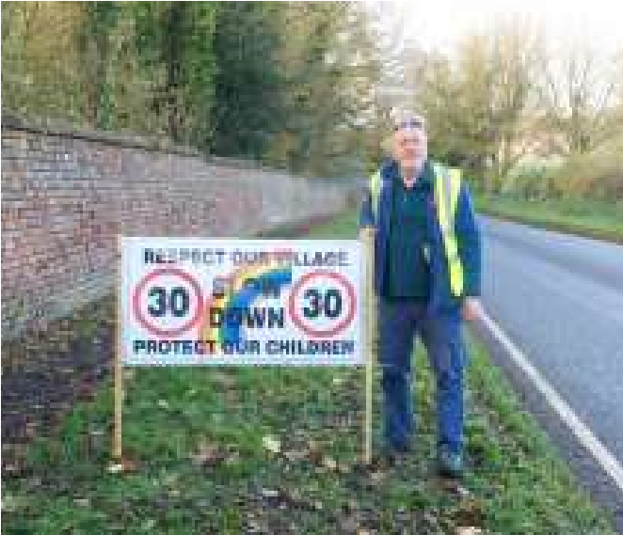
SPEED BANNERS

In support of the Parish Councils Community Plan and Speed Reduction initiative Speed Banners have been erected on all 4 main entry roads to the village. It is hoped that they will encourage motorists to reduce their speed as the enter the village and carry the message that speed reduction helps to protect our village young whilst respecting our village by obeying the law.

Parish Councillor Nick Jones said that this was one of several initiatives the Council | Councillor Nick Jones with the Speed Banner on Beverley Road
were putting forward and further talks with
ERYC about other speed reduction ideas will happen once the traffic survey had taken place. They will include a proposed community speed watch and an initial meeting had already taken place to set the ball rolling.

Watch this space for further details on how you can get involved once training is to be set up.

A note from your vicar

The beautiful gift of weeds
There are many legends associated with Christmas, I would like to share with you a story from Mexico.
Maria and her little brother, Pablo, were very poor but they always looked forward to the Christmas Festival for each year a large crib was set up in their village church, and the days before Christmas were filled with parties and parades.

It was custom that, on Christmas Eve the
whole village attended the church service and they would bring gifts to offer to the Christ Child. There were many wealthy people in the area who would bring expensive and elaborate gifts to present in front of the whole congregation. Maria and Pablo were always saddened because they could not afford to buy a gift for the baby in the manger.

One Christmas Eve, Maria and Pablo set out to go to the service. On their way Maria picked some pretty weeds which were growing by the road side and decided she would offer these as her gift, but by the time they reached the village the little weeds had begun to wilt and Maria began to cry. Pablo comforted his sister and said he was sure that even the most humble gift, if given in love, will be acceptable to Jesus.

When they went into the church some members of the congregation made fun of Maria and her offering but she remembered Pablo’s kind words. Slowly she walked up to the crib scene and placed her little posy next to one of the sheep near the back of the stable.

Suddenly the weeds burst into blooms of brilliant red, and all who saw them were certain they had witnessed a Christmas miracle. From that day on, the bright red bracts were known as the Flores de Noche Buena, or Flowers of The Holy Night, for they bloom each year during the Christmas Season.

Today many of us have this plant in our homes at Christmas – and we call them Poinsettia.

For most of us this Christmas will be very different in many ways.
However you spend it, may you know joy and peace in your hearts and homes.

With my kindest thoughts:

Jane
Christmas Recipes

Poinsettia (contains alcohol) serves 8-9
Both drink recipes are taken from Nigella’s wonderful ‘Nigella Christmas’ book.
1 x 75cl bottle Prosecco or other sparkly dry wine, chilled
125 ml Cointreau or Grand Marnier
500 ml Chilled cranberry juice
Mix everything in a large jug. Pour into wine glasses or champagne flutes.
Mistletoe (Non- alcoholic) serves 10
250 ml Chilled lime cordial
750 ml chilled ginger beer (non alcoholic)
1 x 25ml fresh lime juice
Chill the jug, fill with ice. Pour lime cordial, ginger beer and lime juice into jug and stir gently.

Mulled Fruit Trifle: serves 6
150 ml (1/4 pint ) Mulled Wine
(Or for a non-alcoholic version 150 ml ( ¼ pint) Mulled Cordial (‘Belvior’ do a lovely one, depending on your taste, you may not need to add all the caster sugar)
75g (3oz) Caster Sugar
1 (500g) bag frozen summer fruits
1 teaspoon ground mixed spice
200g (7oz) Madeira Cake, cut into chunks
1 (500g) Carton of Fresh Custard
300ml ( ½ Pint) Double Cream
Edible silver balls (or other festive sprinkle - if you value your teeth!)

Place the Mulled Wine (or cordial) caster sugar, and mixed spice in a pan; bring to the boil.
Reduce heat and simmer for 5 minutes until it is syrupy.
Stir in the still frozen summer fruits.
Scatter the Madeira Cake chunks over the base of your trifle bowl –
1.4ltr/2 ½ pt
Spoon over the fruit and syrup
Top with custard
Whip the cream until soft peaks form.
Place spoonfuls all over the top of the custard Chill for 1 hour before serving Add your festive sprinkles.
(to prepare ahead: make the trifle and stop before the cream is added – refrigerate for up to 24 hours. When ready to serve whip up the cream and dollop on top.)

Jane

Local Birds & wildlife
Well, it looks like there have been record numbers of geese flying over the village this Autumn - and I have looked out at the wrong time every day! Pat texted me on 25th October to report “Hundreds of geese flying over, heading SE!” so I rushed out but missed them. Sheila told me that at the beginning of November she had seen lots of geese – possibly about 1,000 – coming towards her out of the mist; a spectacular sight spreading out over the sky. Joanna also mentioned that “This year there has been a good show of geese flying over morning and evening for the last two months”, so although I have so far missed them it is lovely to know that they are out there in such large numbers.
She has also had more action in her garden then I have so far: “…lots of birds at the feeders, goldfinches, greenfinches, chaffinches, blue, coal, great tits and occasional long-tailed tits. The most disappointing thing is a lack of marsh tits, which seems to have come about since the tree felling and disturbance on the railway line. Still seeing woodpecker, pheasants and sparrowhawks coming through the garden and plenty of buzzards and kites flying around and hearing tawny owls at night. Occasionally we see a barn owl fly over.”
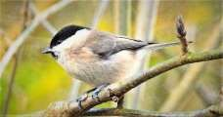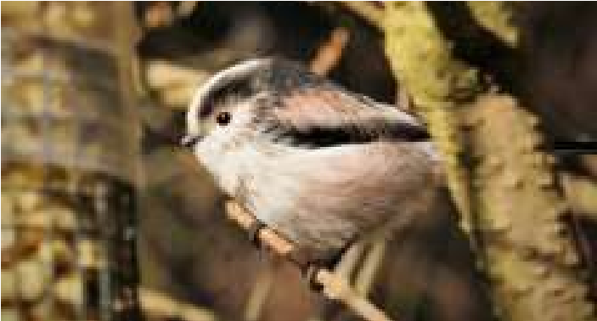
Marsh tit Long tailed tit
This is really interesting as although I am only a few hundred yards away, we have a marsh tit visiting (flitting in, grabbing a seed and disappearing again in an instant), but we have never ever seen a barn owl. I think maybe they are more likely to hunt over the field at the back of the top half of Greenfield Road, while with us backing onto the embankment we hear plenty of tawny owls.
I had an unexpectedly exciting time folding laundry this week, when I glanced out of the bedroom window to see a kestrel hovering over our garden level with me! Something I had certainly never seen before in the 35 years we have lived here. Things have changed so much for the better now – certainly no buzzards or kites around back then!
When I was chatting with Sheila she told me about a large brown bird of prey she had seen near Wilfholme which she thought could be a female hen-harrier; I was near there a couple of years ago with my sister, who is a much better birder than me, and we saw a brown (marsh?) harrier (definitely not a buzzard), so it would be great if they make this area a stopping-off point, even if they don’t settle and
Village hall news
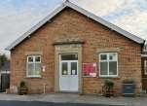
A reminder that committee meetings are now held on the first Tuesday in the month at 2.30pm in the Village Hall if allowed; otherwise we are meeting on Zoom. New members are very welcome - please contact Lyn to find out where the meeting will be held.

Thank you to those who have already completed the survey that was in last month’s Messenger. We will be
collating the results once more have been collected in. Maintenance work has been carried out recently to get us through the winter but then we have plans to improve various aspects of the hall in the coming months.
To book the Village Hall for a future event please contact Lyn Dennis on 219500 or lyndennis456@gmail.com. The charge, including full use of the kitchen equipment, is only £8 an hour with reductions for a half or full day.
The Village Hall &
I should think that lots of us are shopping more on Amazon this year and you could support the Village Hall by switching to Amazon Smile at smile.amazon.co.uk and choosing “Middleton Village Hall” in the supporting box near the top of the page. A small percentage on each purchase goes to our Village Hall.
Local Birds & wildlife continued:
breed here. I know they do get marsh harriers at Tophill Low, and built them a nesting platform to encourage them, though as far as I know it has unfortunately never been used.
Finally many thanks to Jill who sent me a brilliant video of a sparrow-hawk having a very thorough bath in her bird-bath. It seemed to have more white on it’s head than usual – perhaps it’s a juvenile? It would be interesting to see if it turns up again, or anywhere else in the village.
No more Messengers until February now, so I’m wishing you the best possible Christmas, and let me know who turns up at your garden feeders in the colder weather!
Barbara
Lavenderbarbara97@gmail.com 0777 192 7868
Middleton on the wolds ce ve school
Executive Headteacher: Mrs E Harros
Station Road, Middleton on the Wolds, Driffield YO25 9UQ
E-mail:middleton.primary@eastriding.gov.uk Tel: 01377 217323

Senior Citizens Tea
Following Government Guidance Our Senior Citizens Tea this year will not be able to go ahead.
Nativity & Christmas Play
This year we will not be able to invite guests to visit the school to watch the children’s Christmas performance.
Middleton Minis
Following Government guidance, Middleton Minis will not be running for the near future. Once we are allowed to re-open we will inform you via the parish newsletters.
On-going Collections
On-going Collections – We collect used stamps and used batteries. Please note we are not currently collecting used printer cartridges or mobile phones until we can source a new company to collect and recycle them. Thank you.

Middleton on the Wolds Nursery
At Middleton on the Wolds CE (VC) Primary School
 | Providing education for 2, 3 and 4 year olds Monday - Friday.
 | We accept the Government’s childcare vouchers for up to 30 hours of free provision for 3 year olds (conditions apply)
 | Additional sessions can be purchased for £13.50 per session for 3 year olds and £15.75 for 2 year olds.
 | Lunchtime sessions are £1.75 (free if children attend for the whole day) with the option to purchase a school meal for £2.40.
 | Children are welcome in the term after their 3rd birthday for funded places.
For further details please contact: Sharon Stone
Email: middleton.primary@eastriding.gov.uk Tel: 01377 217323

We break up for Christmas on Friday 18th December and return to school on Tuesday 5th January.
Thank you for all of the support that we have received throughout 2020.
All staff and pupils at Middleton School wish you all a very Merry Christmas and a Happy New Year.

MIDDLETON MOVERS
Thursdays 2.00pm

During September and October we were able to continue with Movers in the Village Hall, keeping to strict government guidelines on distancing, sanitising and face-covering. We did the seated exercises as usual, followed by either New Age Kurling or Bocce. It was good to be together once again with friends and get our bodies stretching and exercising gently.
In normal times we would follow the exercises and games (we have quite a lot of equipment eg skittles, crossbows, bean bags) with a gathering round a table for a cup of tea and a biscuit and a game of dominoes or a quiz to give the brain a bit of a work out too.
Come the November lockdown we were unable to meet in the Village Hall so 2 of us tried the seated exercises over Zoom. It worked surprisingly well so it will now be a weekly class until we are again allowed to meet in person.
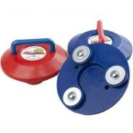
If you would like to join us please drop me an email - it doesn’t matter if you are a Movers regular or just feel you would like half an hour of gentle exercise. Lyn
Bocce

New Age
Kurling

lyndennis456@gmail.com

Middleton book group
Bernard Cornwell, a prolific author, writing to 2 novels a year in his heyday, now, at 74 only manages one a year. Sword of Kings is the 12th and penultimate book in his Saxon series which follow the life of Uhtred of Babbenburg, the present area of Northumbria. The first six were serialised by the BBC as The Last Kingdom
This historical novel which shows difficulties between pagans and Christians and the north and south. King Alfred had wanted to unite the country but his follower King Edward divided the area he ruled between his two sons when he died which let to war between the two.
The book club members had mixed opinions on this book and not all of them actually read it. There was a lot of bloodthirsty violent battles which did not encourage people to read it, unless interested in that historic period
This Is Going To Hurt by Adam Kay covered the mistreatment, neglect and unreachable expectations put on trainee and new doctors. Although the book was a serious read of the early days in his medical career and detailed many gruesome and difficult situations, it was written in a way that managed to portray some of these in a comedic way which made it a very readable book. Adam Kay accomplishes this by incorporating humour and personal anecdotes as he progressed through his medical training and his eventual resignation from his medical career
Most of the club members enjoyed Adam Kay’s style of writing, although some of them found the content of bad language and very gruesome situations difficult, but we all felt we now have a better understanding of the difficulties of trainee and newly qualified doctors and they recognised this to be at least one of the reasons for the NHS to struggle to keep new qualified doctors in their chosen profession.
Kath

As our houses and gardens are out of bounds at the moment because of COVID 19 we are meeting on Zoom. For the short term we have changed the day of the Book Group meetings to the second Friday in the month, still at 2.00pm. Do get in touch if you are interested in joining us: 219500 or lyndennis456@gmail.com.

Books for discussion in December and January:

“To Everything a Season” by Sherri Schaeffer
“The Paper Bracelet” by Rachel English
“The Little Paris Bookshop” by Nina George & Simon Pare
“The Salt Path” by Raynor Winn

SCOUT POST

Due to COVID 19 the Scout Post has been cancelled
this year.

Sue Howden

ADVERTISING COSTS for the Messenger
Rates Month Year

Whole Page £25 £150

1/2 Page £15 £100

1/3 Page £10 £60
Full colour - Print run 500 copies
Contact: Tina 01377 217242, middletonflyer@yahoo.com
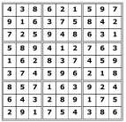
Quiz answers

Dingbats:

Wrapping paper

Presents under the tree

Twelfth night

Seasonal greetings

White Christmas

Word wheel: poinsettia

1

Six points

2

Seasons Greetings

3

Gaspar/Caspar, Melchior, and
Balthasar/Balthazar,

4

Deep pan, crisp and even!

5

Tiny Tim (A Christmas Carol)

6

Blue Christmas

7

A Song on his Drum

8

The Muppet Christmas Carol

9

Baby David (Christmas Day 1999)

10

Morecambe and Wise

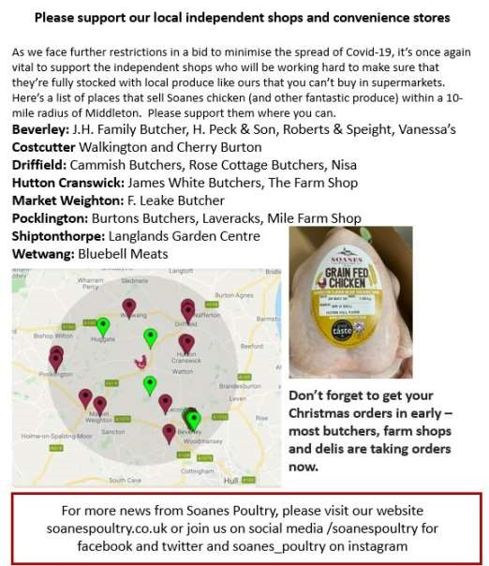
Advertising Feature

Advertisement
Advertising Feature

Regular group activities

Weekly Groups
Monday Pilates |  |  | 6.00-7.00pm Village Hall *
Tuesday YCA |  |  | 2.00pm Zoom
Wednesday Line Dancing |  |  | 7.30-9.00pm Village Hall *
Thursday Middleton Movers |  |  | 2.00-3.00pm Village Hall or Zoom
December  1 Village Hall Committee  7 Parish Council  11 Book Group  January  - Middleton Womblers  - Parish Council  - Village Hall Committee  8 Book Group |  |  | 2.30pm  7.00pm  2.00pm  10.00am  7.00pm  2.30pm  2.00pm |  | *when permitted  Village Hall or Zoom  Zoom  Ring 219500 for venue  Lime View  Zoom  Village Hall or Zoom  Ring 219500 for venue
 |  | LOCAL CONTACTS Bell Ringing Chris Atkin |  |  |  | 217285
 |  | Book Group/Middleton Movers |  | Lyn Dennis |  | 219500
 |  | Bowls Club |  | Rob Bradley |  | 217435
 |  | Country Women’s Association |  | Christine Johnson |  | 217374
 |  | First Responders |  | Chris Brent |  | 219469
 |  | Line Dancing |  | Pat Pottage |  | 217516
 |  | Methodist Chapel |  | Jane Gray |  | 07870 562455
 |  | Middleton Messenger |  | Mike Kelly |  | 07713 620912
 |  |  |  | Lyn Dennis |  | 219500
 |  |  |  | Tina Walker |  | 217242
 |  | Middleton Womblers |  | Andrew Naylor |  | 219072
 |  | Parish Clerk |  | Sandra Morrison |  | 01262 470496
 |  | Pilates |  | Ian Stephenson |  | 07973 755717
 |  | Reading Rooms |  | Kath Bentley |  | 217456
 |  | Recreation Club |  | Dave Newlove |  | 07901 833784
 |  | St Andrew’s Church |  | Rev Jane Anderson |  | 219471
 |  | St Andrew’s Church Warden |  | Roger Lowe |  | 217656
 |  | Table Tennis |  | Louise Newlove |  | 217801
 |  | Village Hall |  | Lyn Dennis |  | 219500
 |  | Village History |  | Geoff Wisher |  | 217517

